1. ***MEASURE TABLE***

It is not a good practice to keep the measures in one table where they are created. To resolve this issue when there are many measures, we can create a measure table. So, a measure table is just like any other table in Power BI but it only contains measures.

For example: there can be 5 measures taking care of business intelligence of our report like ‘sales last year’, ‘sales for past 3 months’ etc. There can be some measures used for sorting.

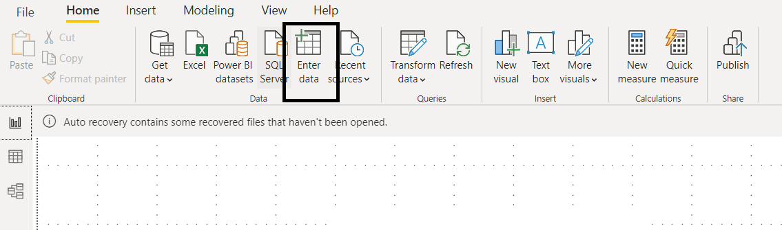

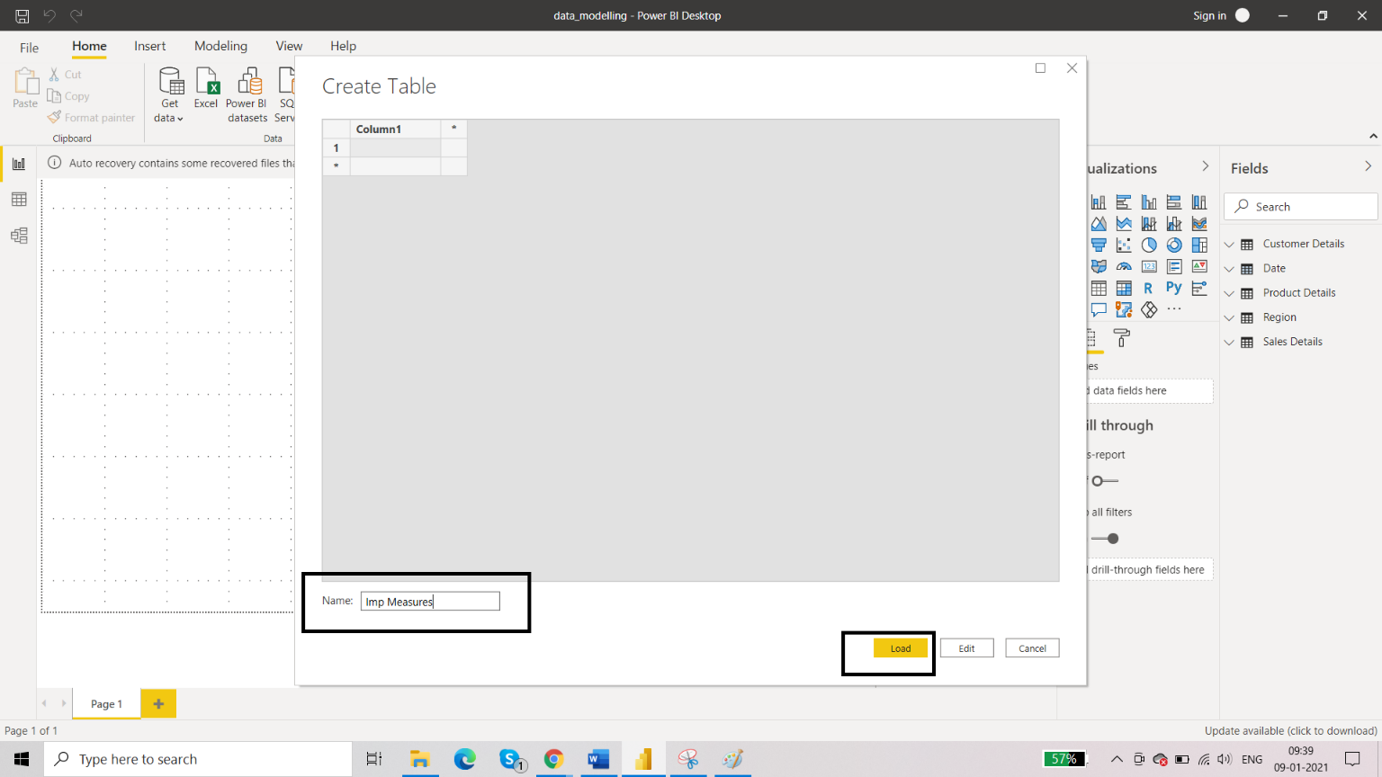

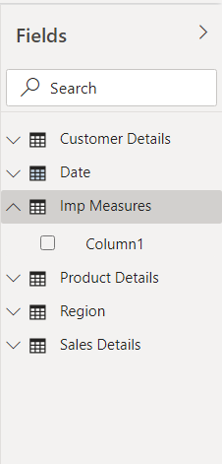

Now the table for measures is created. So, we can move the measures from different tables to this table.

To do that, select the measure that you have created and go to Measure Tools:

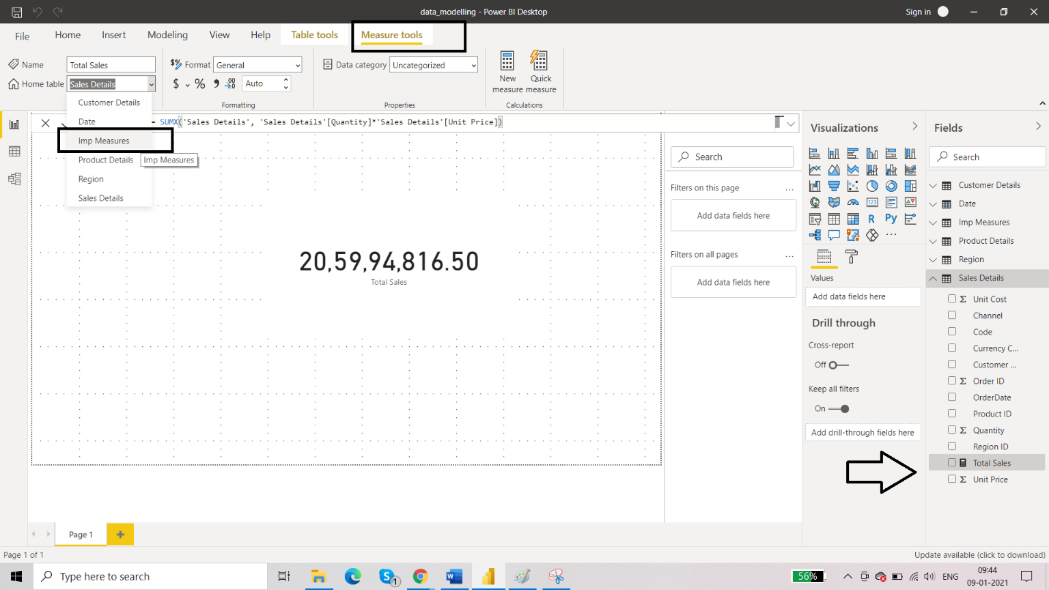

Change the home table from Total Sales to Imp Measures. You can delete the column that is empty in the Imp Measure table. Collapse the Field Pane and open again, you will notice that the icon for measure table is changed.

Data Model View:

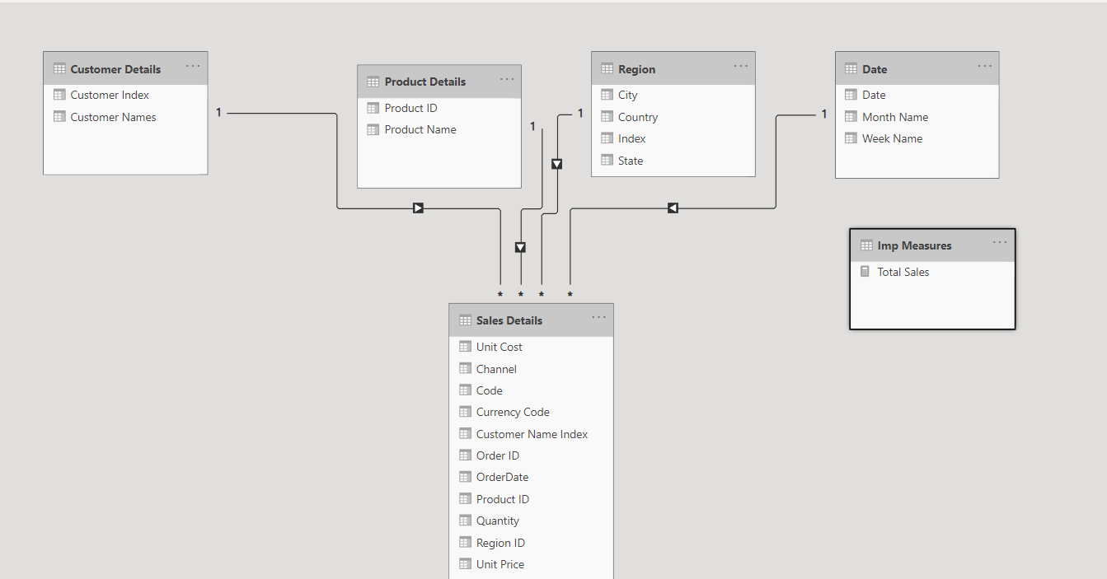

We can keep this table at the third level and there is no need to establish relationships with this table. So, every measure table will be listed here in this level alongside this Imp Measures table.

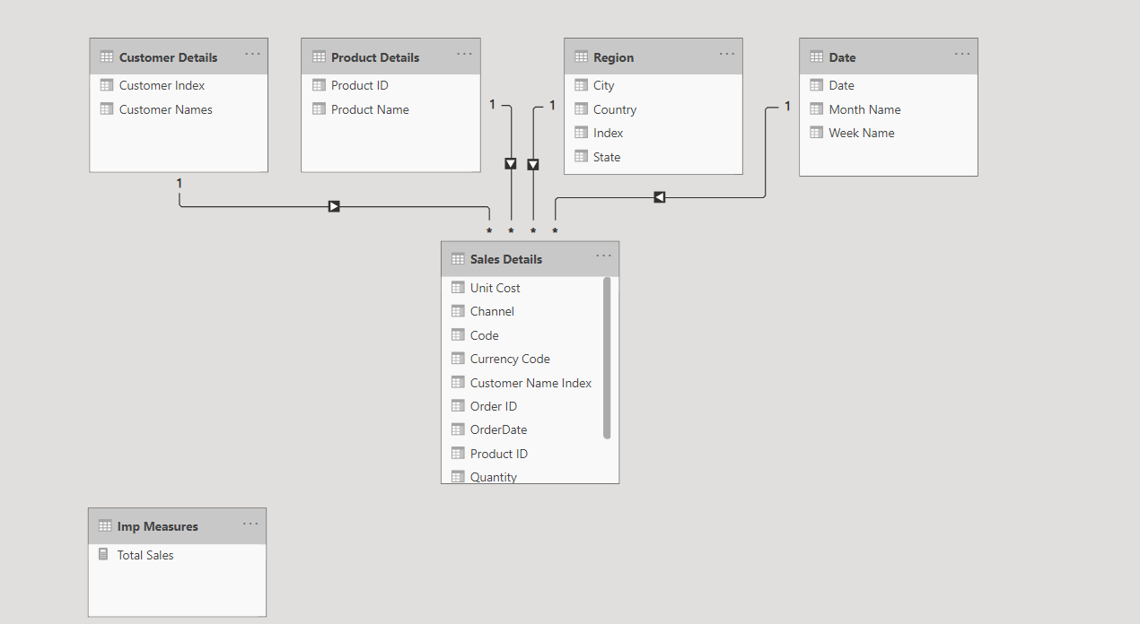

1. ***New Measure: Total Cost***

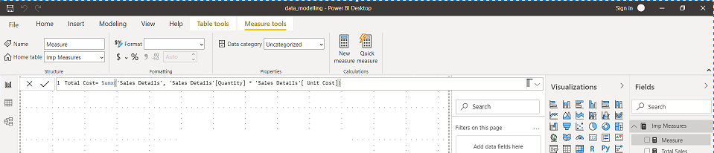

We can visaulize this using card:

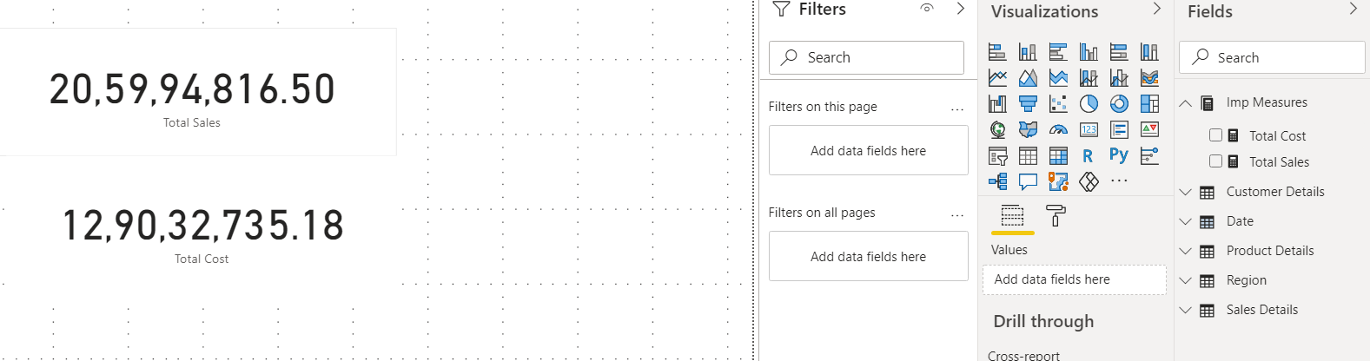

So none of the tables were affected. We just used column names and table names and created a measure in a separate table altogether.

1. ***New Measure: Total Profit***

We are going to make new measure by using existing measure.

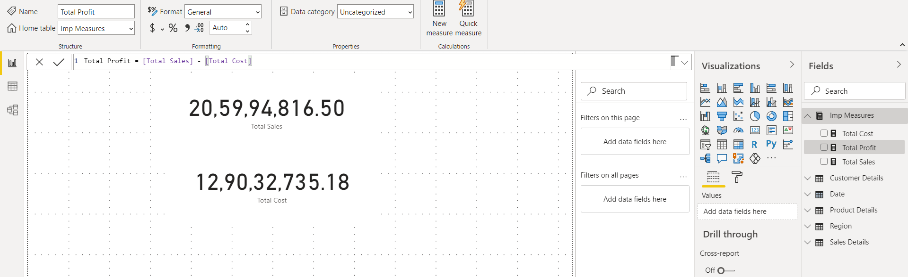

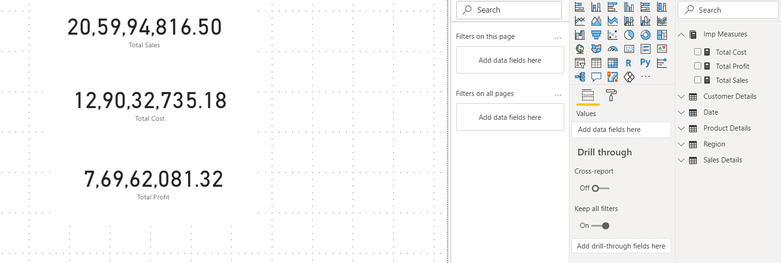

1. ***Create Report***

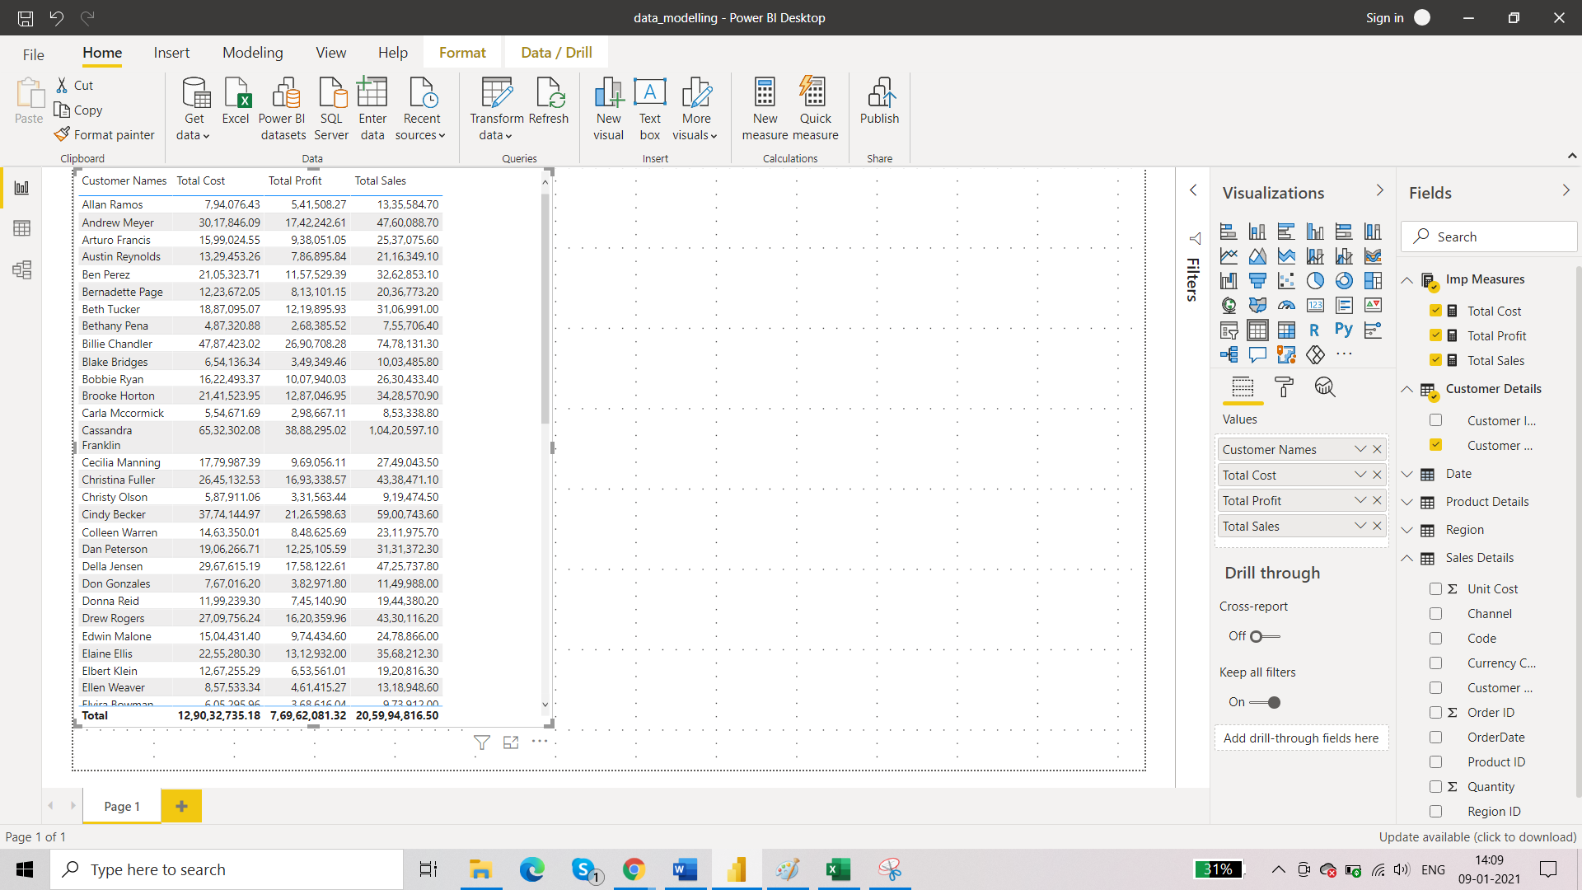

Now format the measures to add $

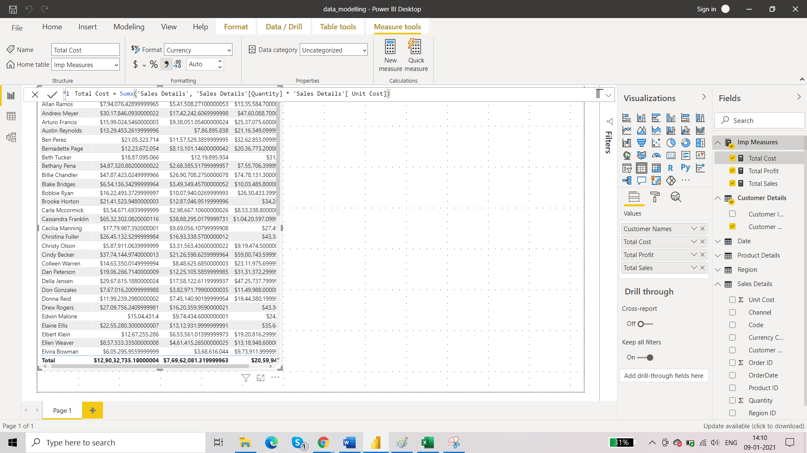

1. ***Find the profit percentage***

Again, create a new measure using dax.

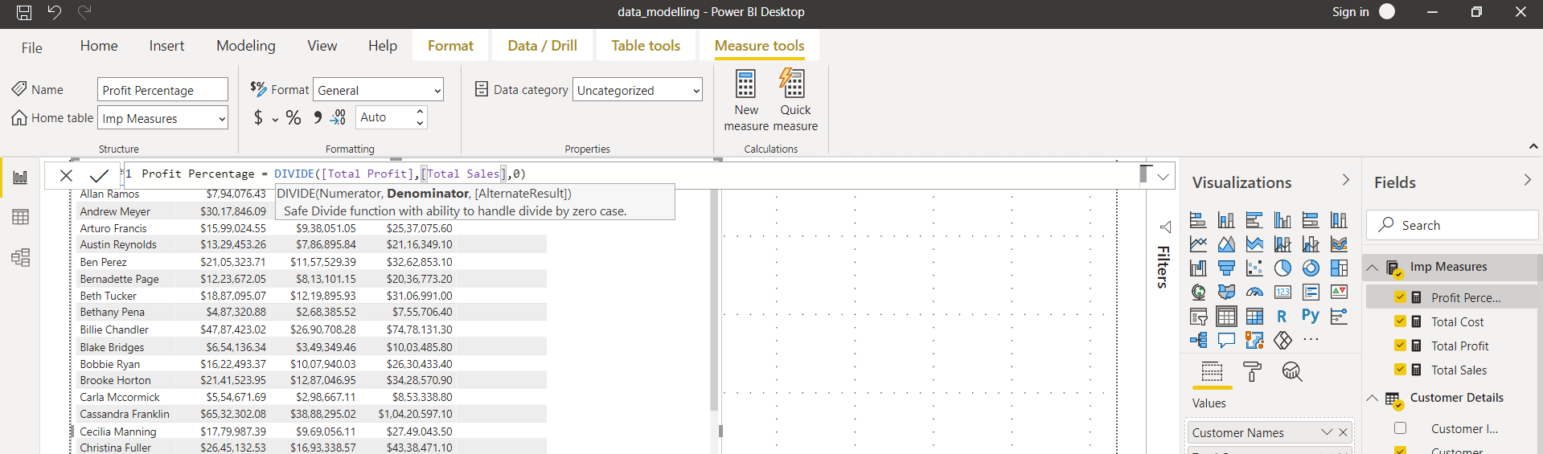

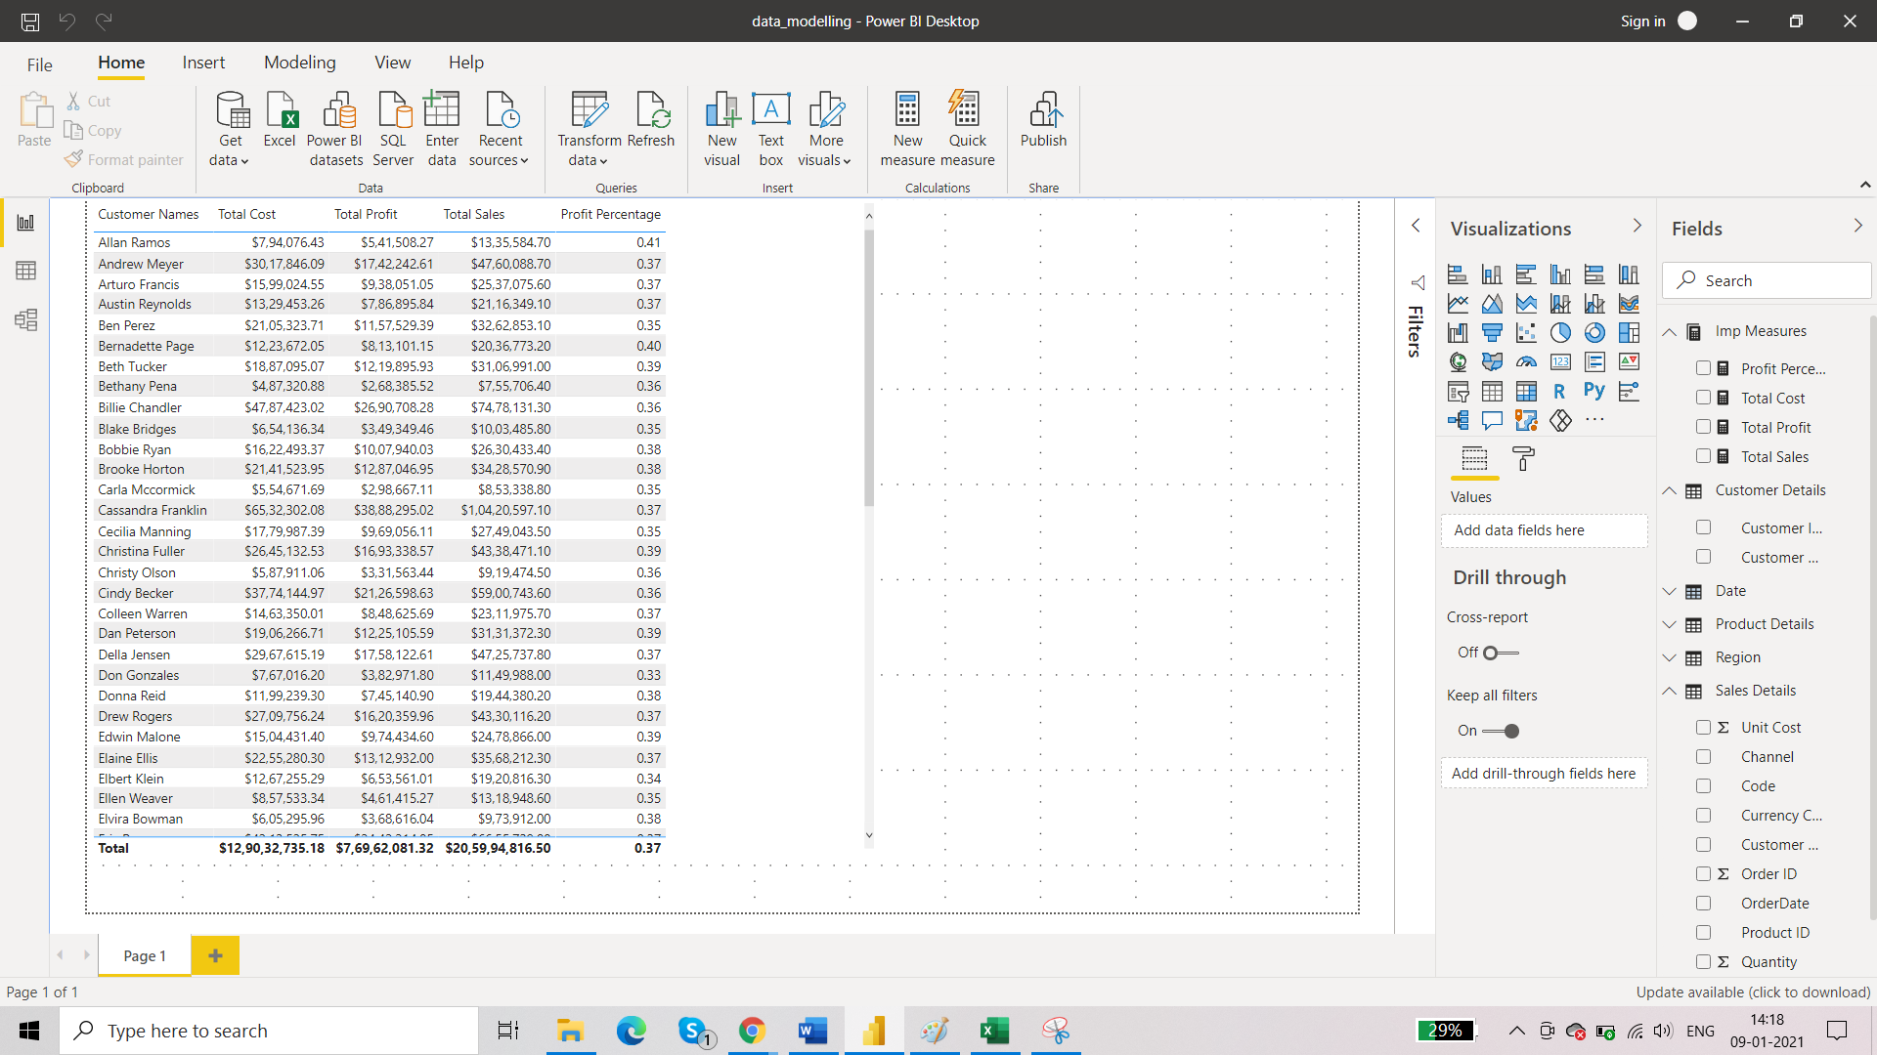

1. ***New Measure: Number of Transactions***

These can be purchases. These can be sales. In simple words, each row of Sales Details table represents a transaction. So total number of rows in Sales Details table are total number of transactions.

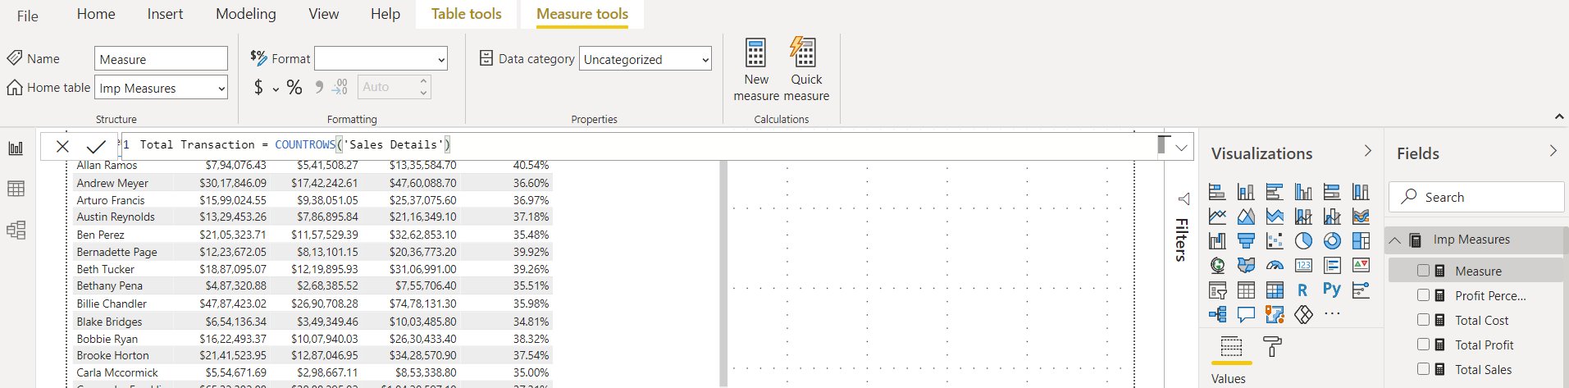

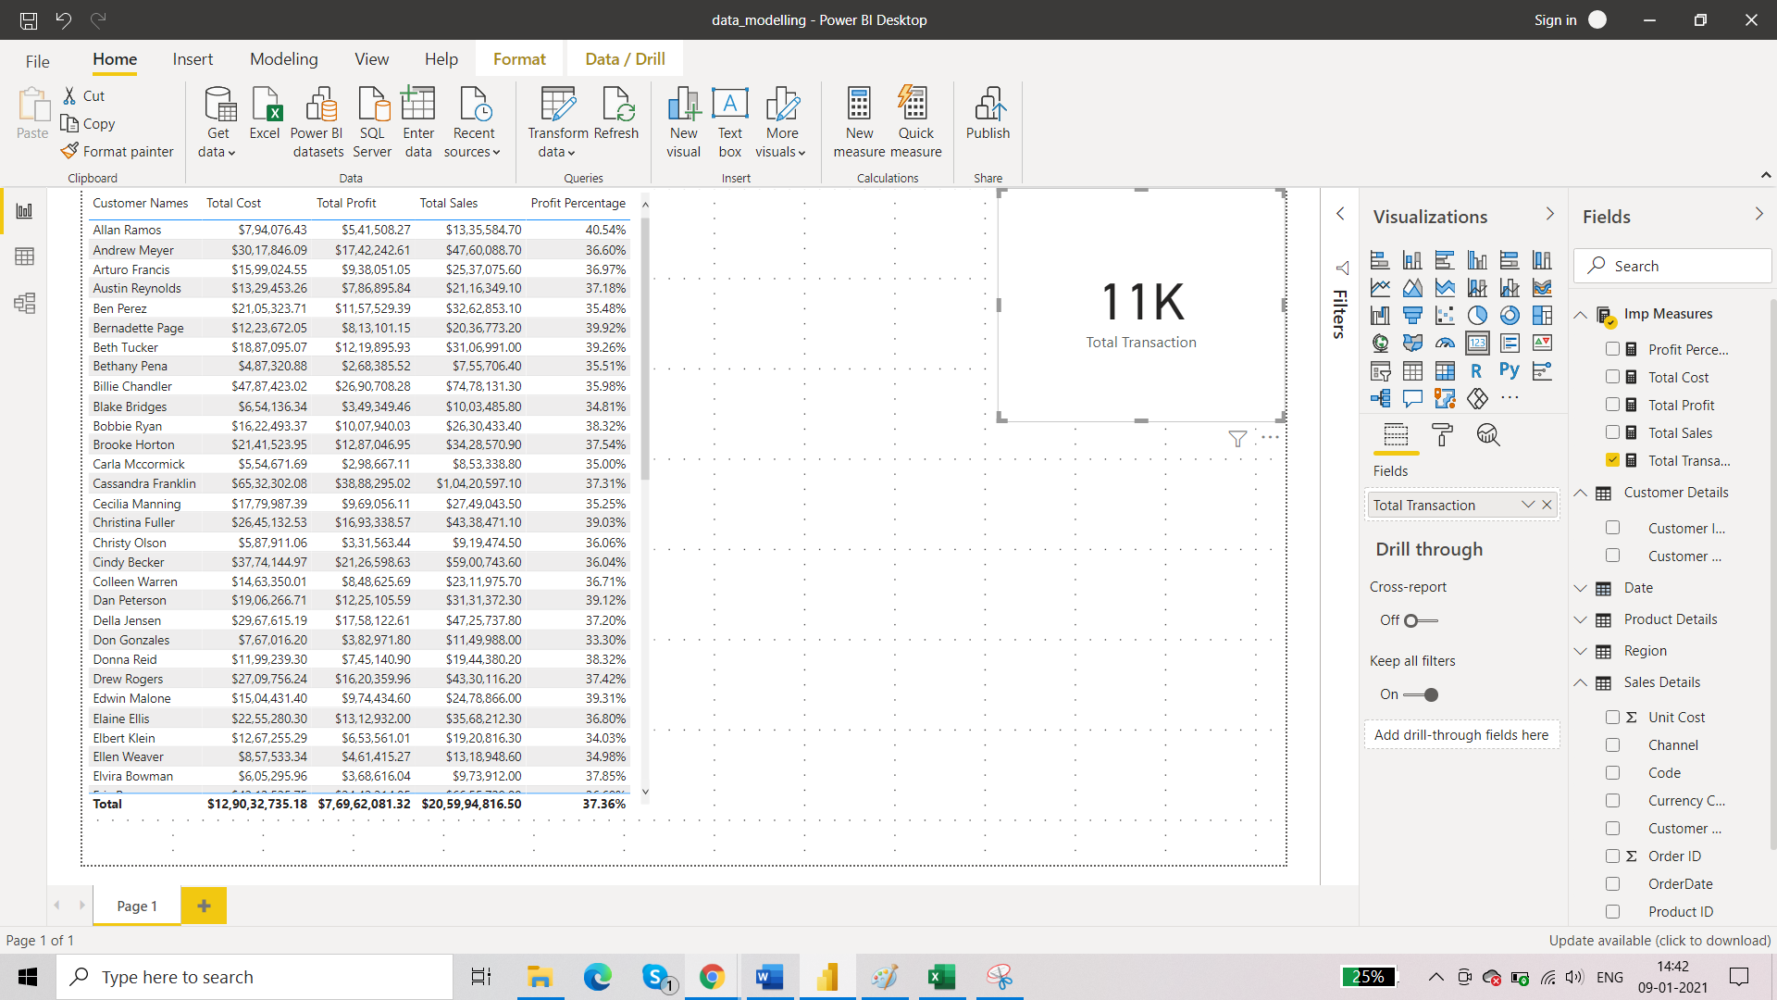

1. ***Time intelleigence table***

Time intelligence analysis are those analysis where time component is involved. Create a new measure table:

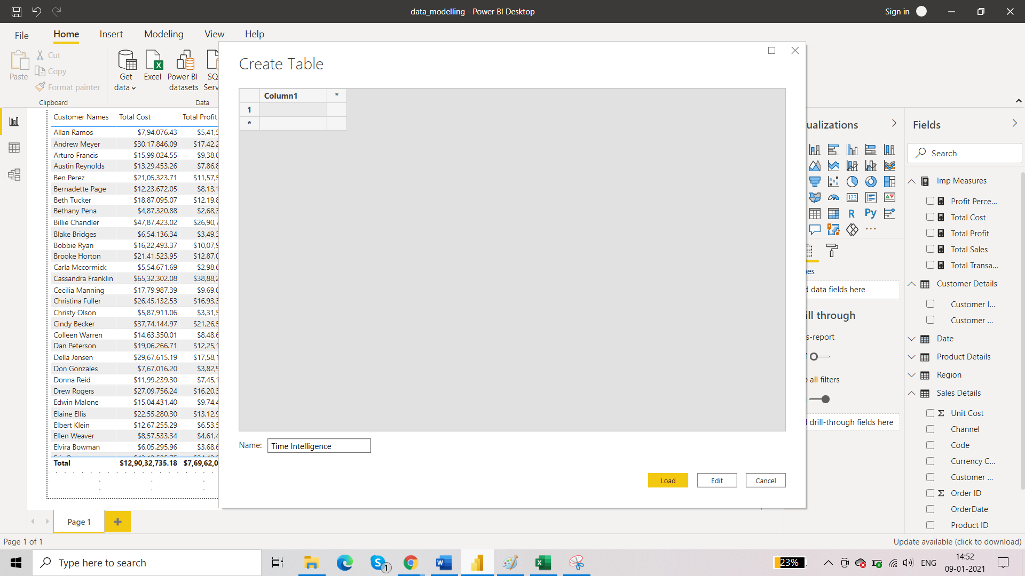

1. ***New Measure: Last year sales (time intelligence)***

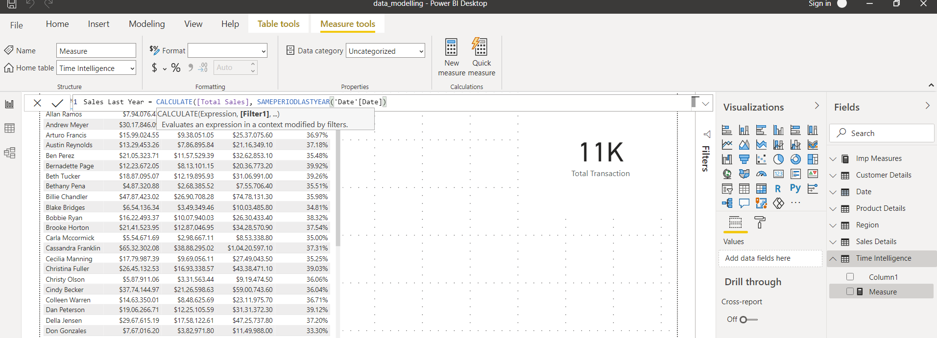

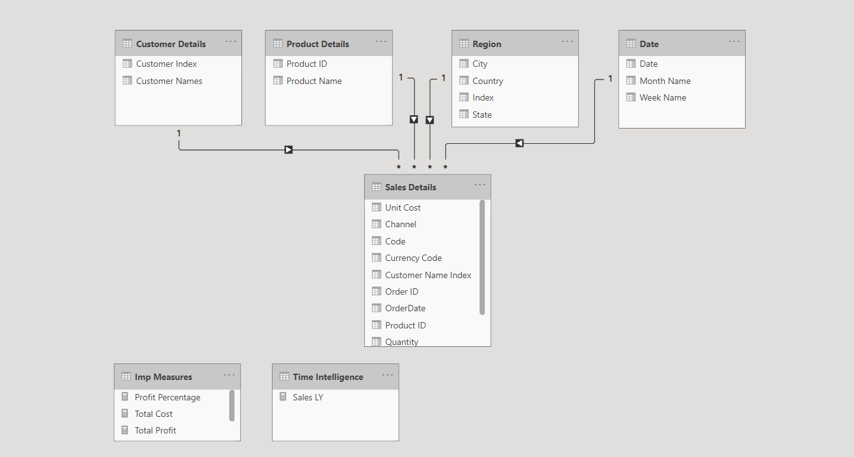

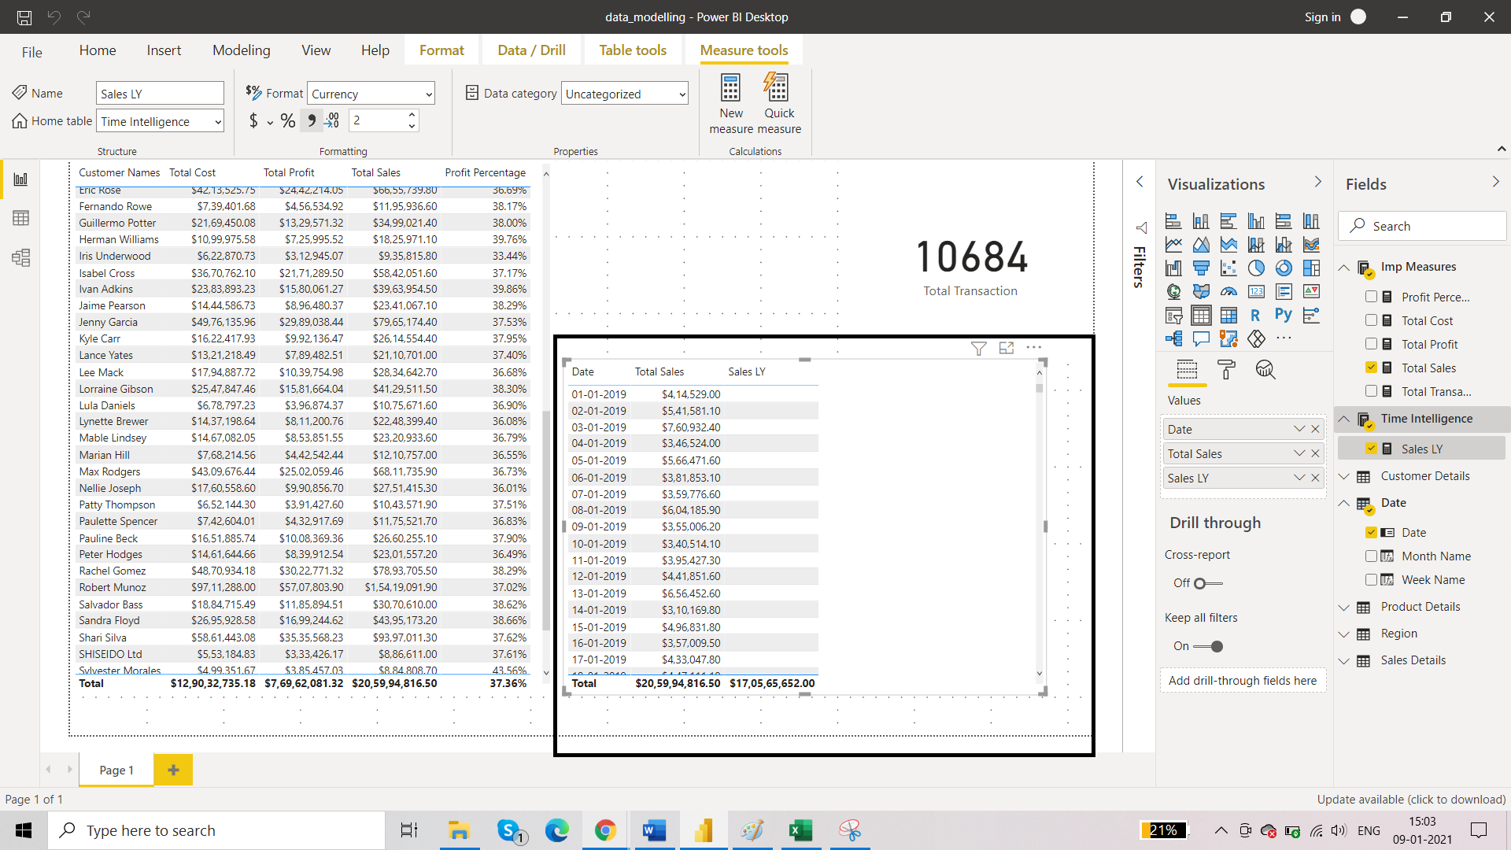Sales LY is empty for date 2019 because we don’t have data for 2018.

For 2020, Sales LY will correspond to sales of 2019:

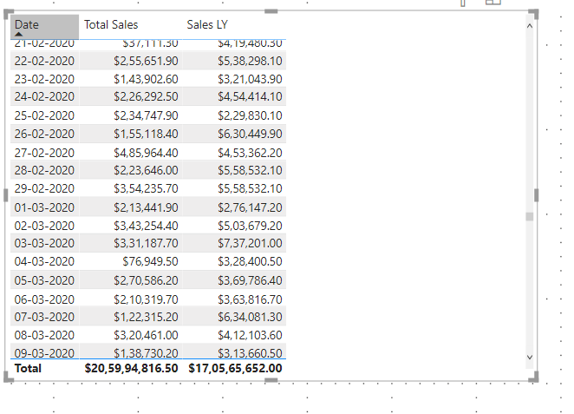

1. Sales LY 2

Now, in to make Sales LY more dynamic that is if we want sales last year in terms of days and months too we can use Sales LY2. We are going to use DATEADD instead of SAMEPERIODLASTYEAR.

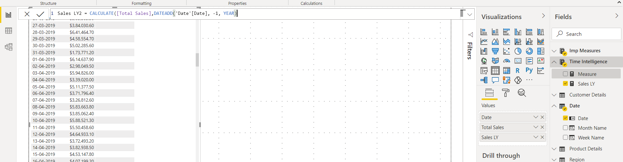

1. Profit LY

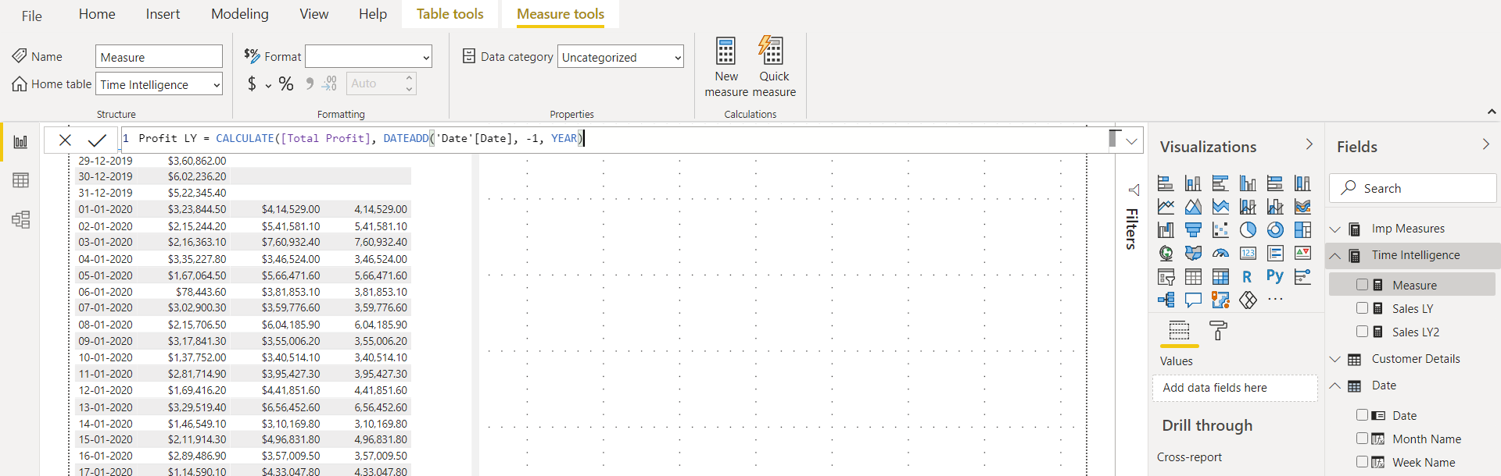

1. Year of Year Sales Difference

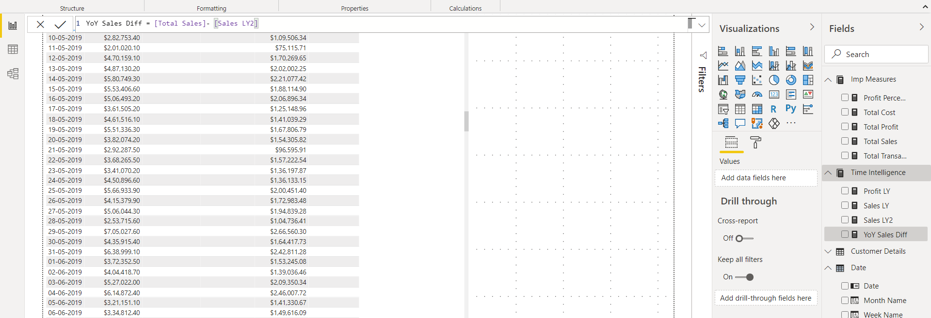

1. Create Data table by using m function

Go to transform data option. Add new source and select blank query.

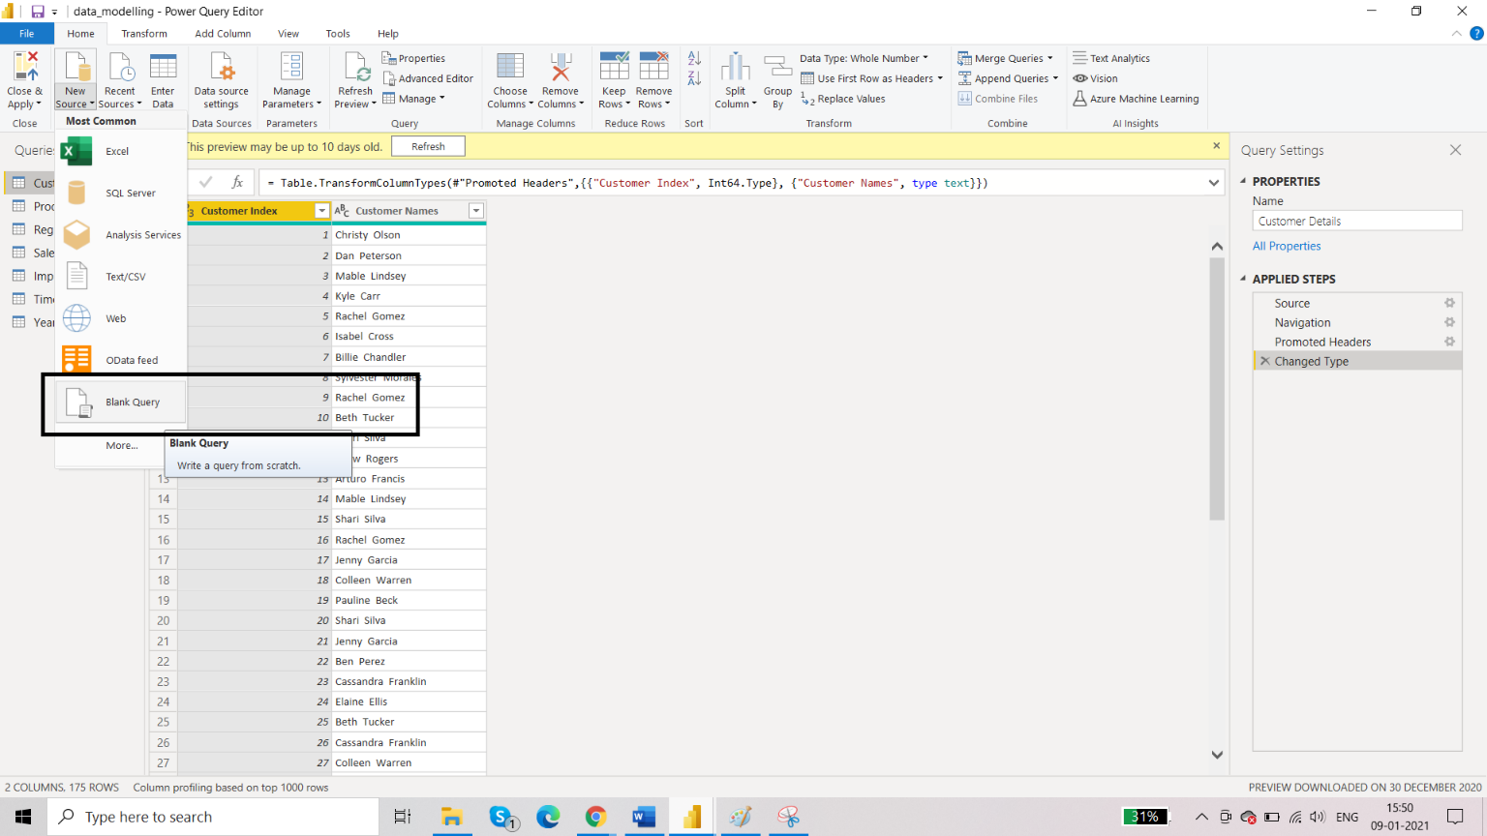

Click on advanced editor. This is where we write m function codes.

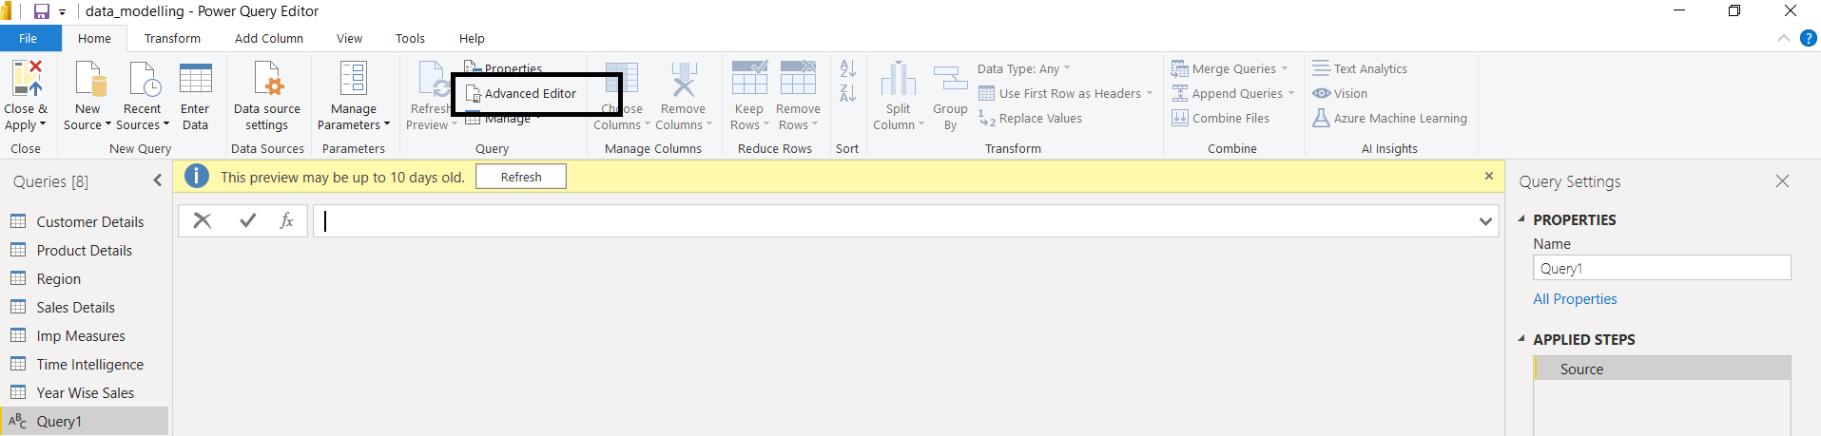

Paste the code here.

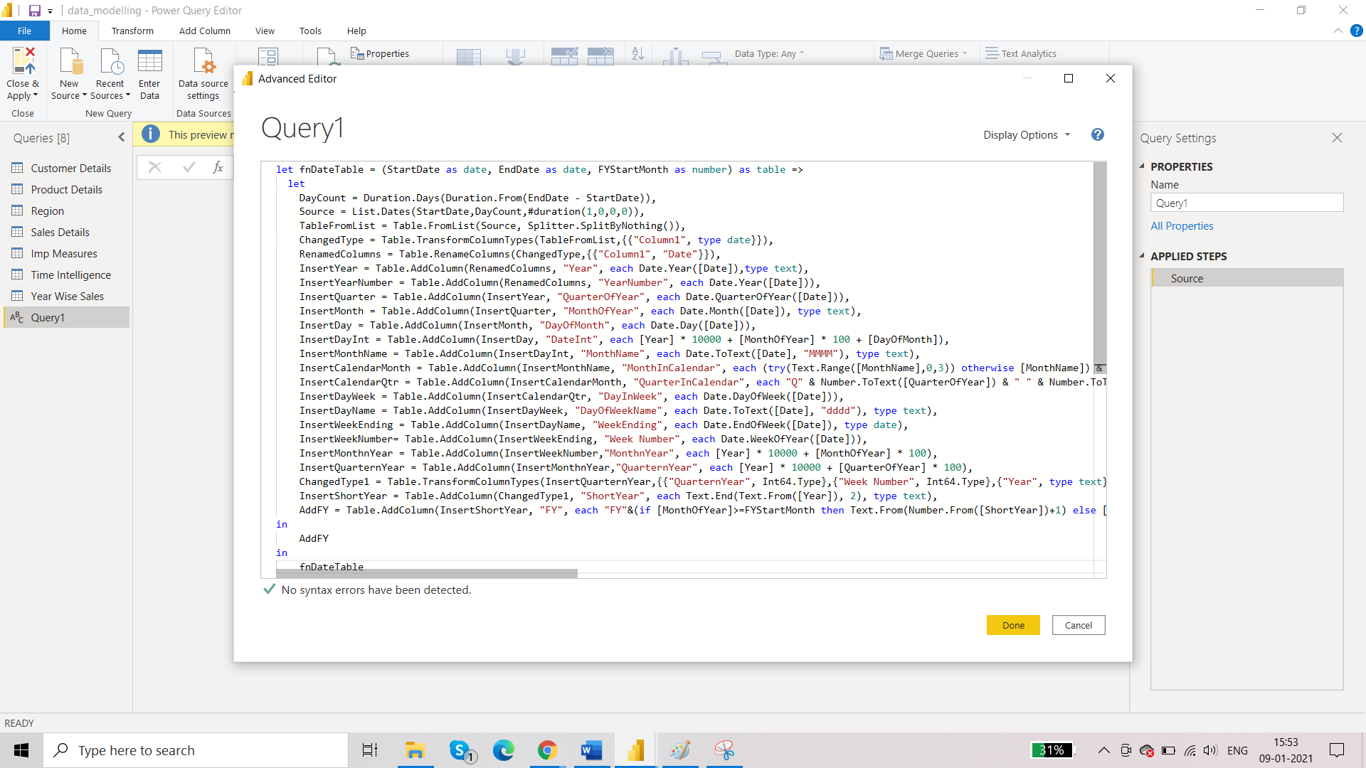

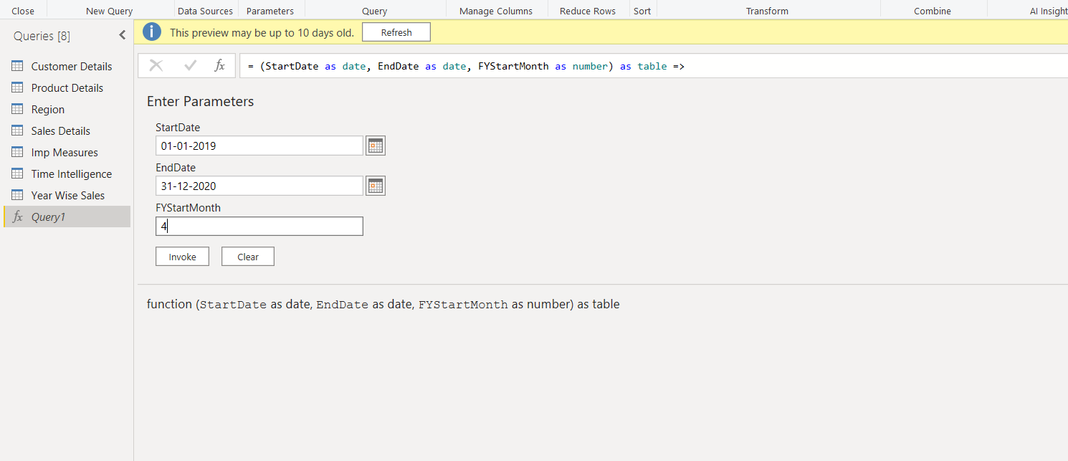

Click on invoke.

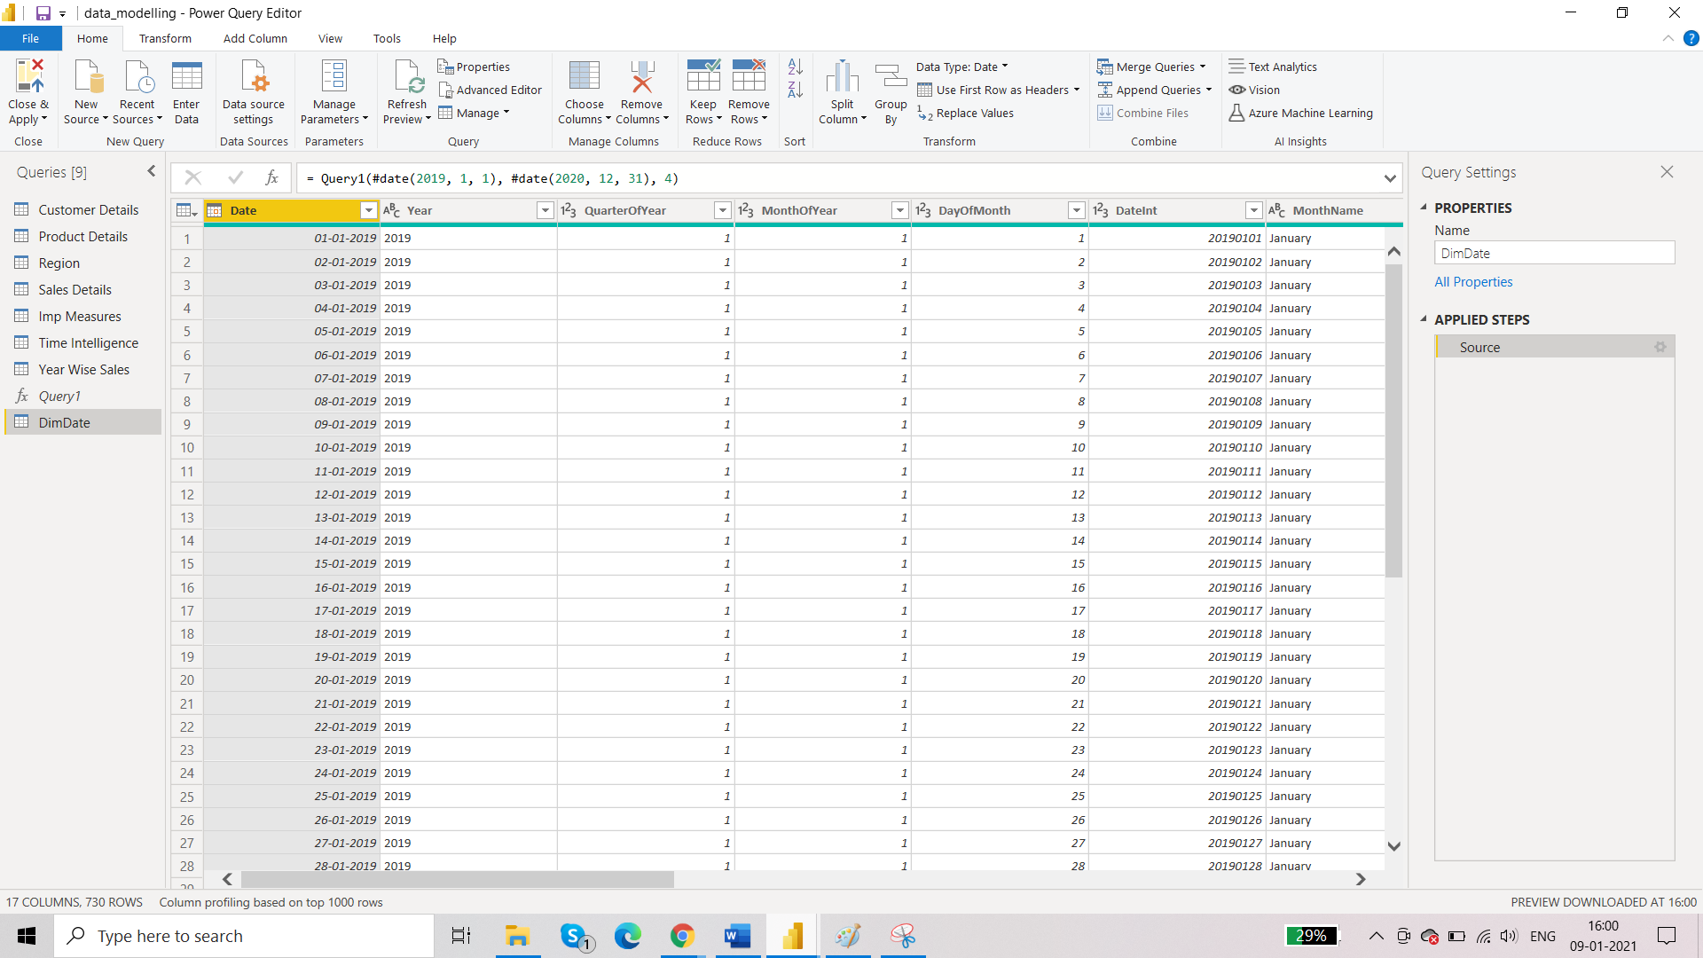

Click on close and apply

Old Date table is no longer required.

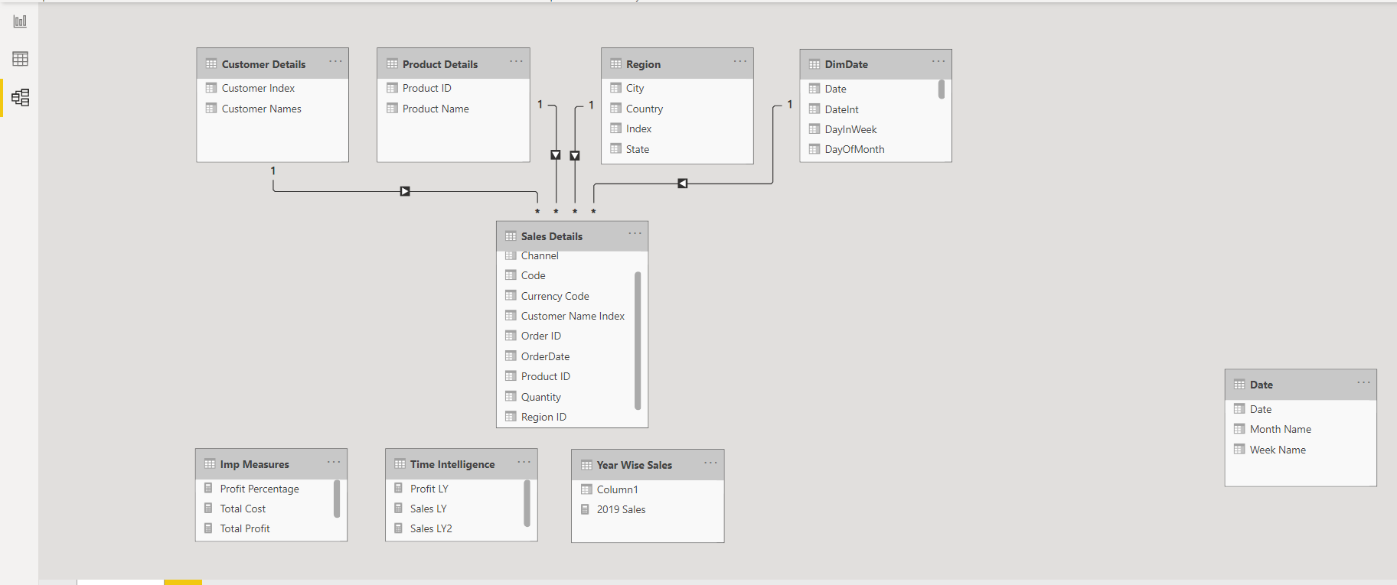

Where ever you had used Date table in the formulas, you have to change it to DimDate.

1. Year wise Sales

Create a new table.

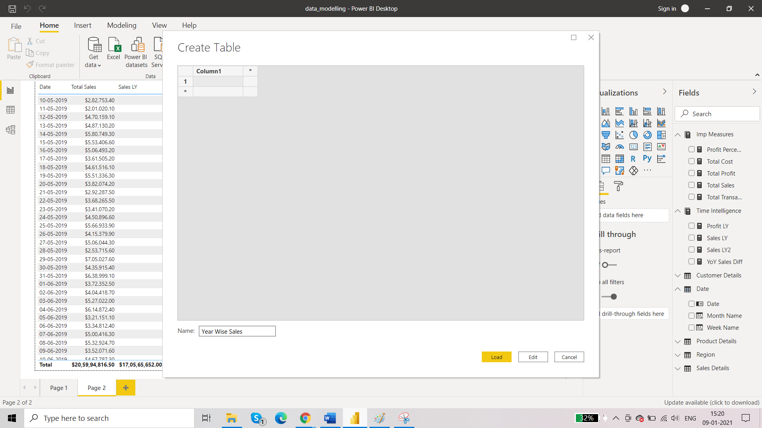

1. New Measure: 2019 sales(year wise sales)

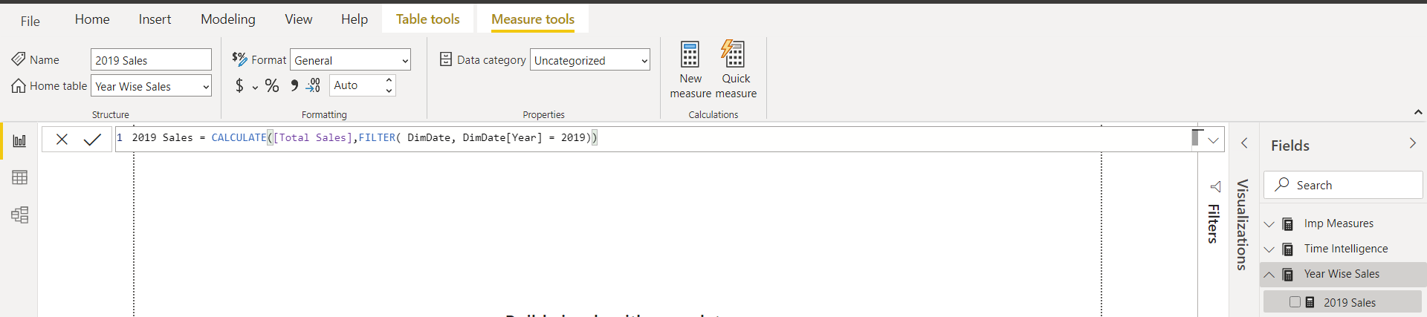

There comes a error when visualising.

Go to transform data and change the data type of year column in dimdate table from text to umber.

1. New measure: 2020 sales(year wise sales)

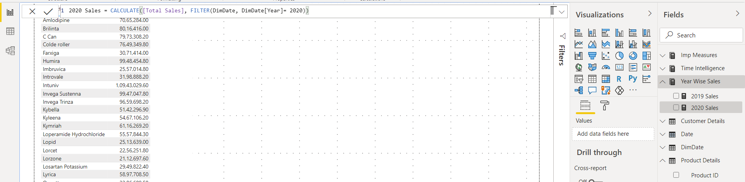

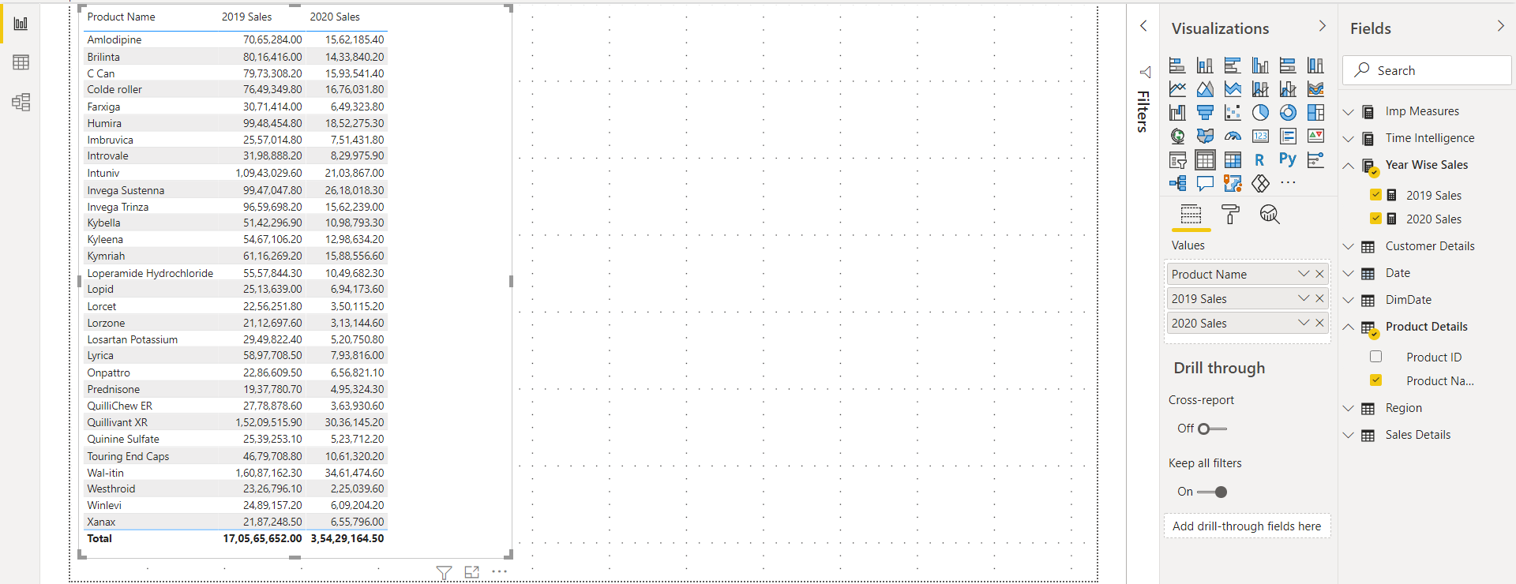

1. Average Daily Sales

Time part is involved. So we will go under time intelligence table.

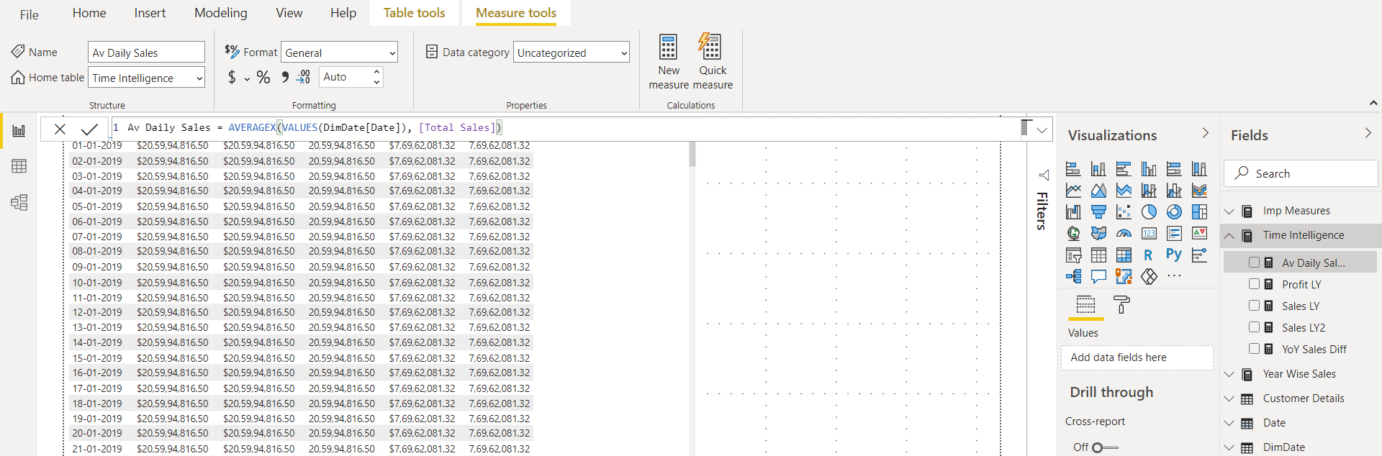

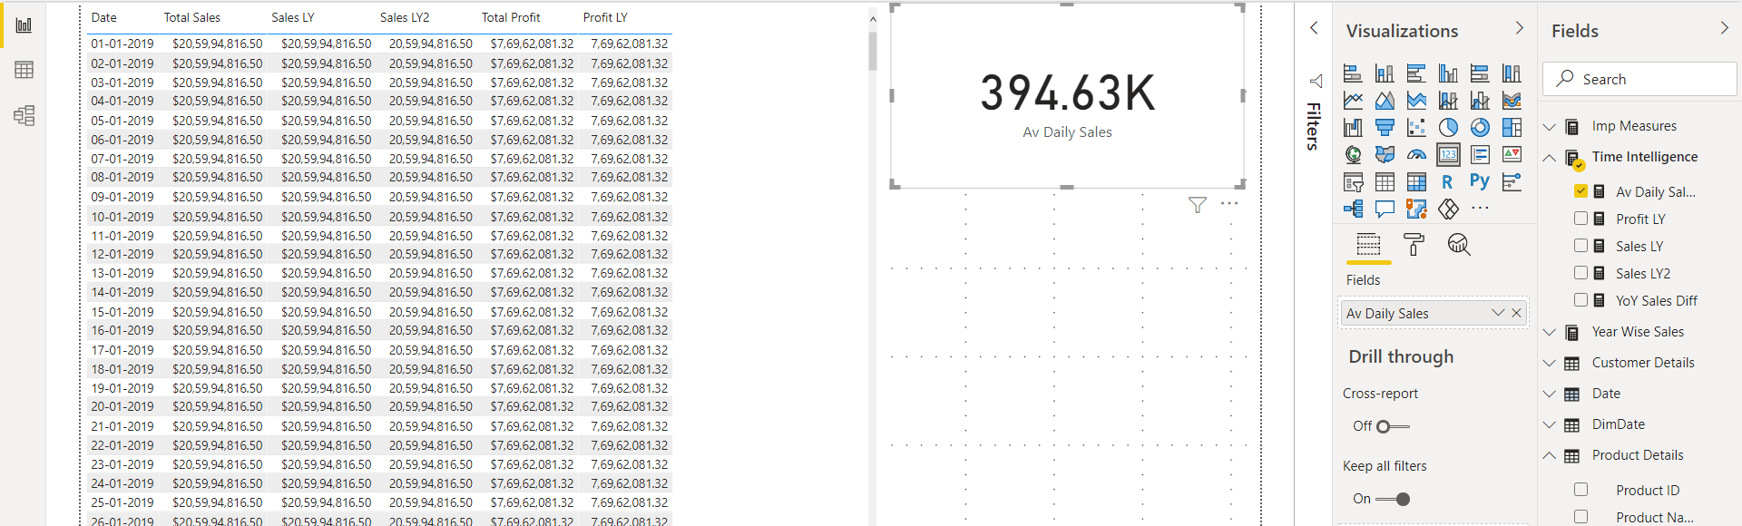

1. New measure table for TOP 10 – like attributes

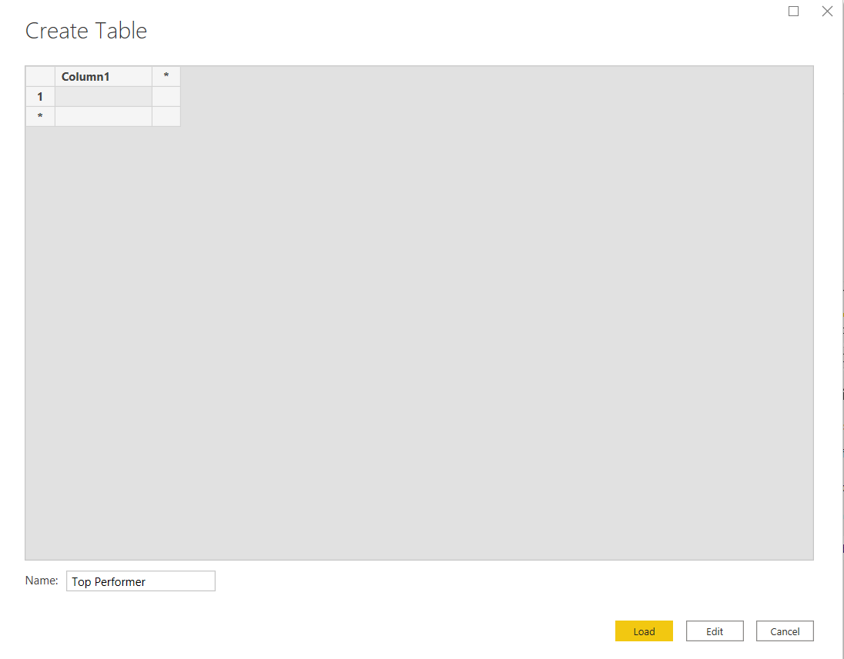

1. Top 5 customer

We will first think about the tables that we are going to require.

Then think about the DAX function: (shift+enter to go to next line)

* Calculate fucntion – for total sales
* Filter function – for customer name
* Rank function – to sort cutomers on the basis of sales
* If function – once we reach top 5, we will want to stop
* Blank function

Top 5 Customers = CALCULATE([Total Sales], FILTER(VALUES('Customer Details'[Customer Names]), if(RANKX(ALL('Customer Details'[Customer Names]),[Total Sales],,DESC) <=5, [Total Sales], BLANK())))

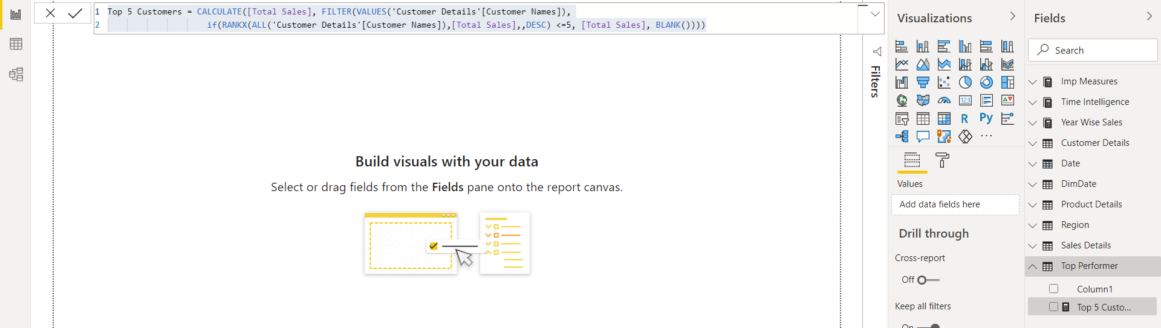

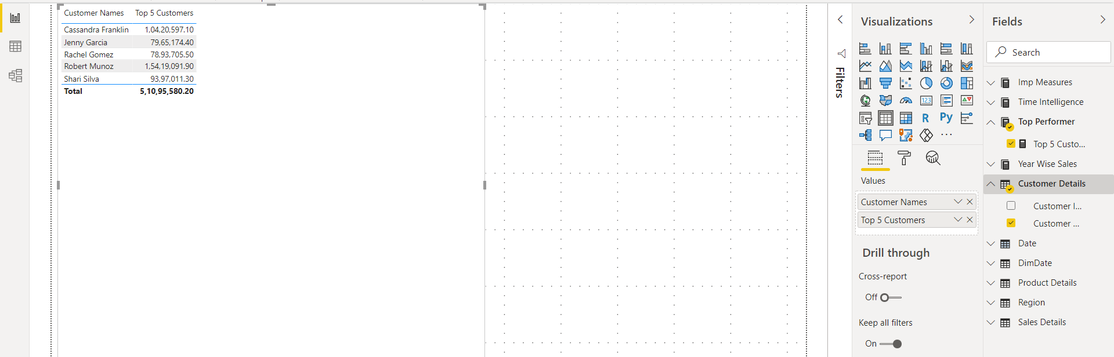

Click on Top 5 Customers

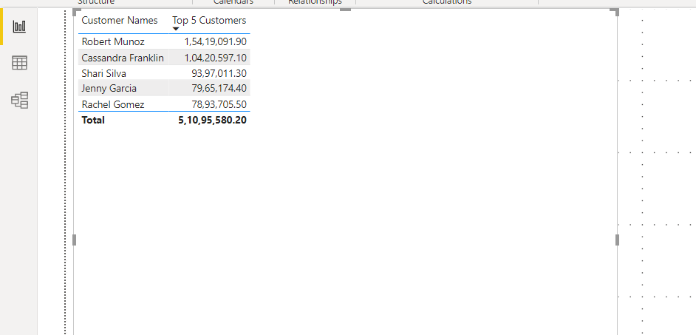

1. Top 5 Products:

Top 10 Products = CALCULATE([Total Sales], FILTER(VALUES('Product Details'[Product Name]),

if(RANKX(ALL('Product Details'[Product Name]),[Total Sales],,DESC) <=5, [Total Sales], BLANK())))

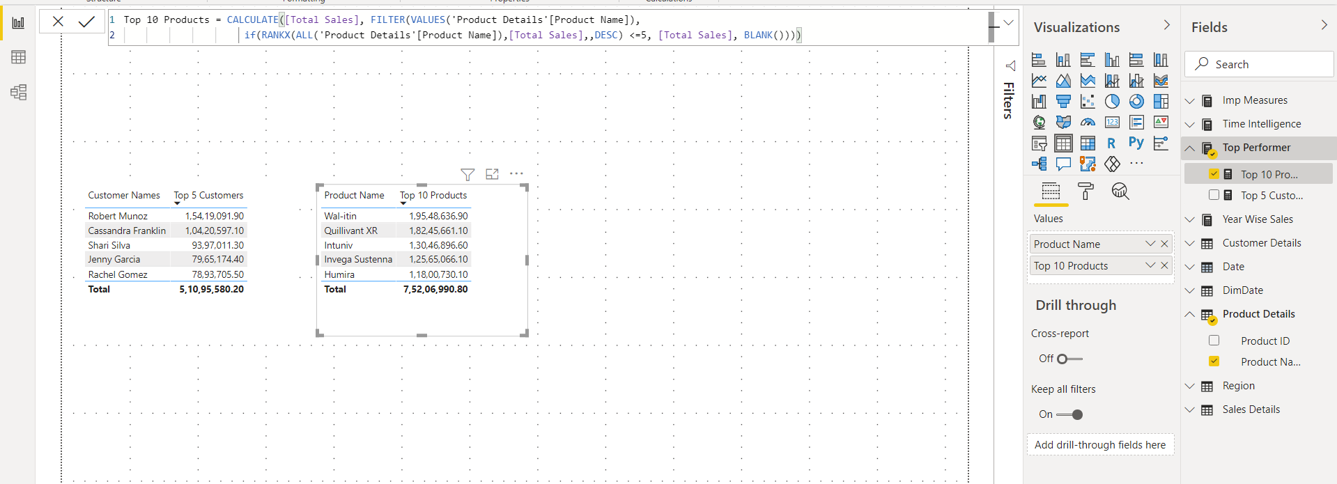

1. Top 5 Cities